LAB ASSIGNMENTS 1: Git & GitHub

Practice following categories of command as demonstrated in the session.

1. basics commands

2. git log

3. git diff command

4. git rm command

5. undo changes using git checkout command

6. git reference (master and head)

7. git reset

8. git ignore

9. git branching and commands

10. merging and conflict

11. deleting branches

12. rebashing

13. git slash

14. git remote commands

15. git taging

Git reset

soft

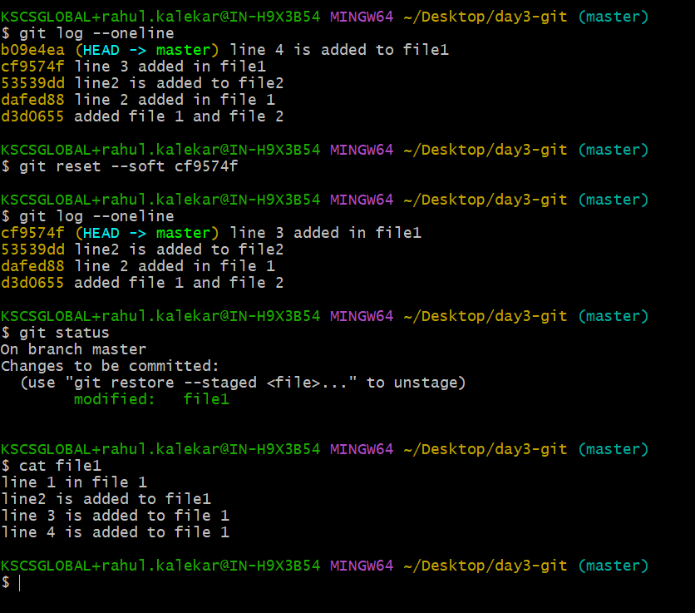

Hard ,

Deletes the changes from working directo

Mixed

Stash

But if we create another file , file 4, and don’t git add . , it does not push to stash

Git branch

